Version 1

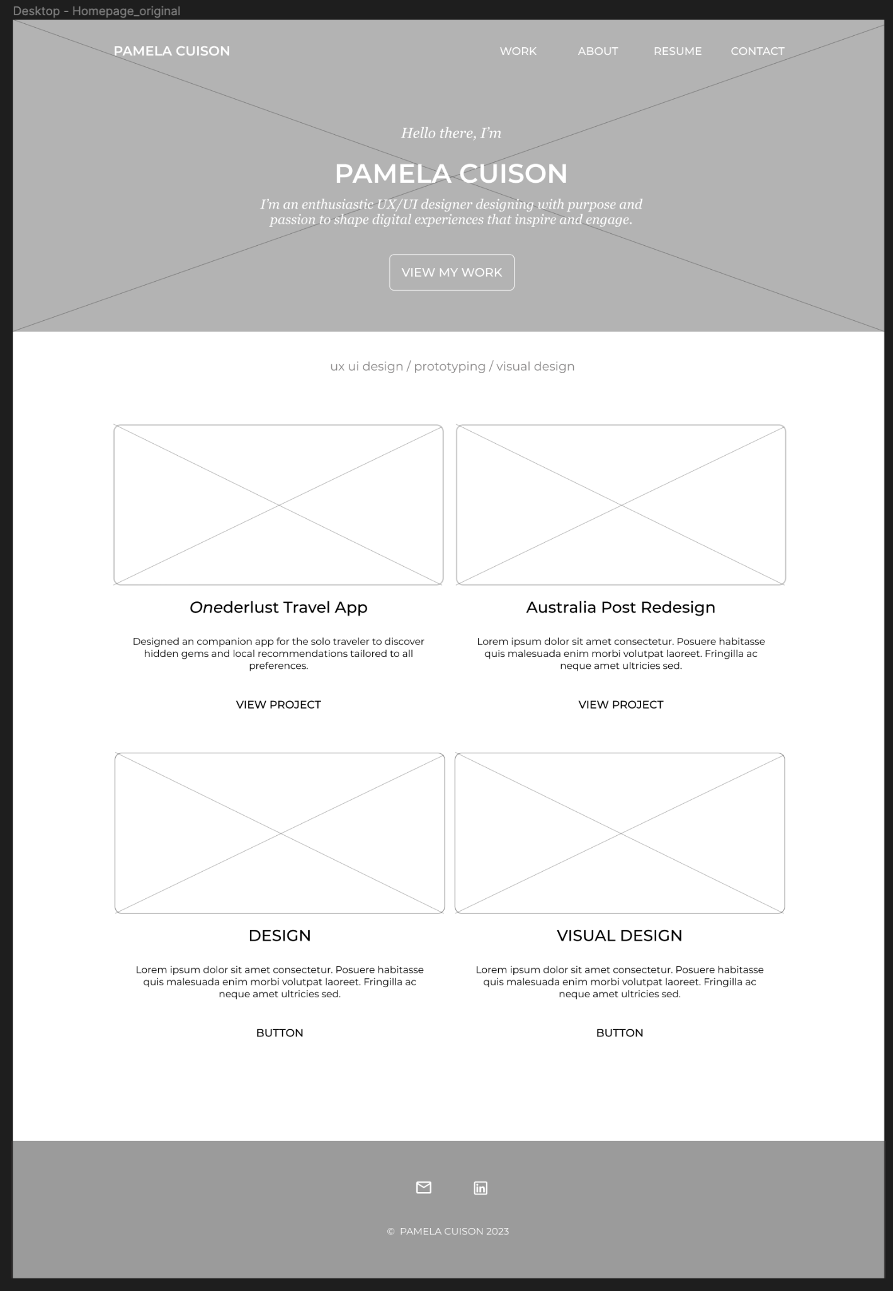

Feedback:

* “Link to “Work” is in three places. You might want to break it up or something so that it’s not redundant.”
* I like the layout. It’s really clean.
* Navigation is in a good place. I like the fonts you use but it may be a bit small to read.

Version 2: Created a jumbotron splash page and then a dedicated page to Work to showcase various projects.

